

*Journal of Geophysical Research – Oceans*

Supporting Information for

# A Lagrangian Snow-Evolution System for Sea Ice Applications

Julienne Stroeve1,2,3, Glen E. Liston4, Samantha Buzzard3,5, Lu Zhou6, Robbie Mallett3, Andrew Barrett2, Mark Tschudi7, P. Itkin8, Michel Tsamados3 and J.S. Stewart7

# 1University of Manitoba, Centre for Earth Observations Sciences, Winnipeg, MB R3T 2N2, Canada

2University of Colorado, National Snow and Ice Data Center (NSIDC), Boulder, CO 80303, USA

3Univeristy College London, Earth Sciences, London, WC1E 6BT, U4Colorado State University, Cooperative Institute for Research in the Atmosphere (CIRA), Fort Collins, CO, 80523, USA

5Georgia Institute of Technology, Atlanta, Georgia, 30332, USA.

6Ministry of Education Key Laboratory for Earth System Modeling, Department of Earth System Science, Tsinghua University, Beijing, China

7University of Colorado, Colorado Center for Astrodynamics Research (CCAR), Boulder, CO 80309, USA

8UiTThe Arctic University of Norway, Department of Physics and Technology, Tromsø, 9019, Norway

**Contents of this file**

Figures S1 to S13

Tables S1 and S2

**Additional Supporting Information (Files uploaded separately)**

Captions for Movies S1

**Introduction**

This supplement includes some supporting figures and tables to the main body of the document, correlation length scale analysis of Operation Ice Bridge Data versus SnowModel-LG, as well as an animation of snow accumulation from 1 August 2013 to 31 July 2014.

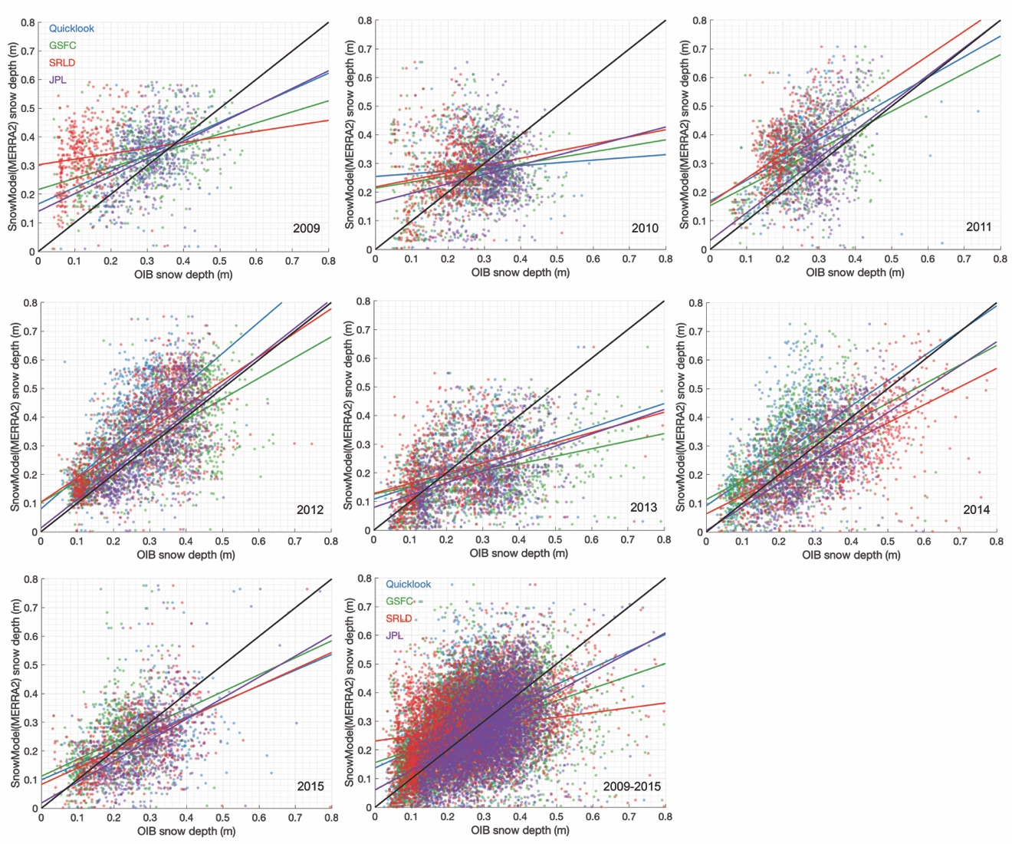

**Figure S1.** Scatter plots betwen OIB-estimated snow depths and those from SnowModel-LG forced using MERRA-2 atmospheric reanalysis. Shown are results from 2009 to 2015.

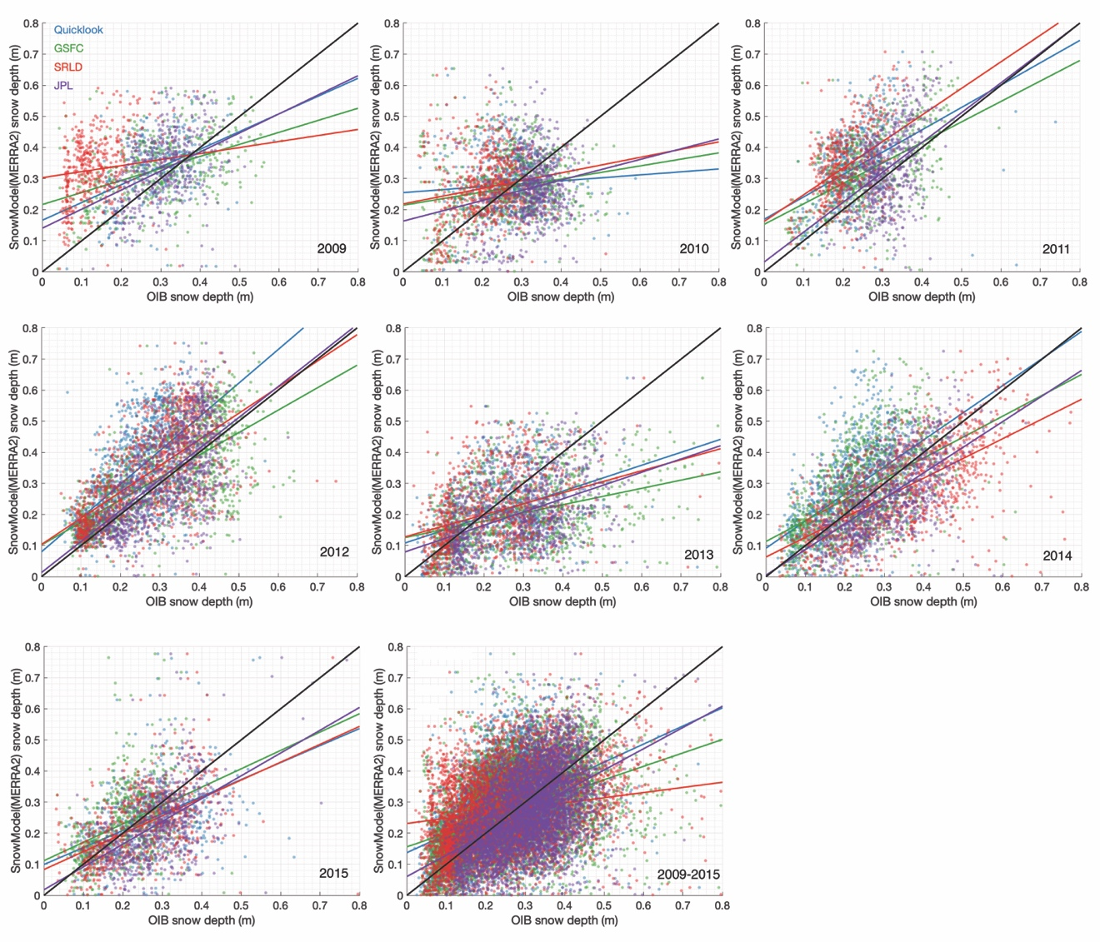

**Figure S2.** Scatter plots betwen OIB-estimated snow depths and those from SnowModel-LG forced using ERA5 atmospheric reanalysis. Shown are results from 2009 to 2015.

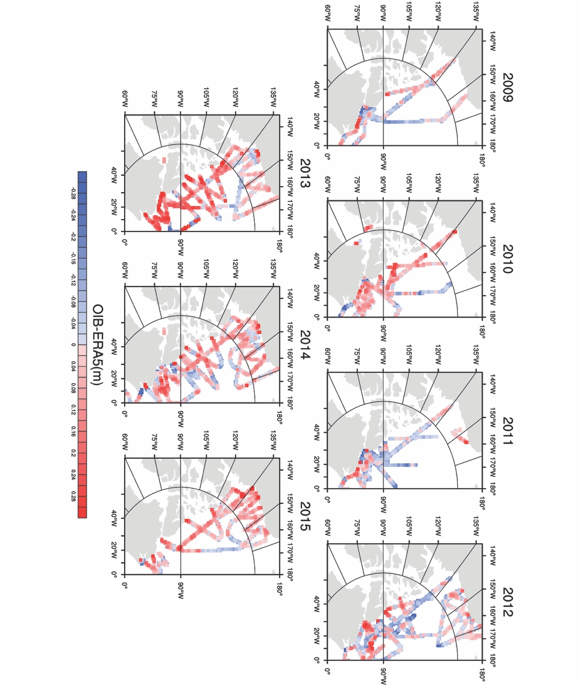

**Figure S3**. Difference in mean OIB snow depth, as represented by an average over four data products (GSFC, QuickLook, JPL and SLDR), to that from SnowModel-LG runs using the ERA5 reanalysis. Results are shown for each year from 2009 through 2015. The OIB data swaths have been widened by one 25-km grid cell on all sides to improve visibility.

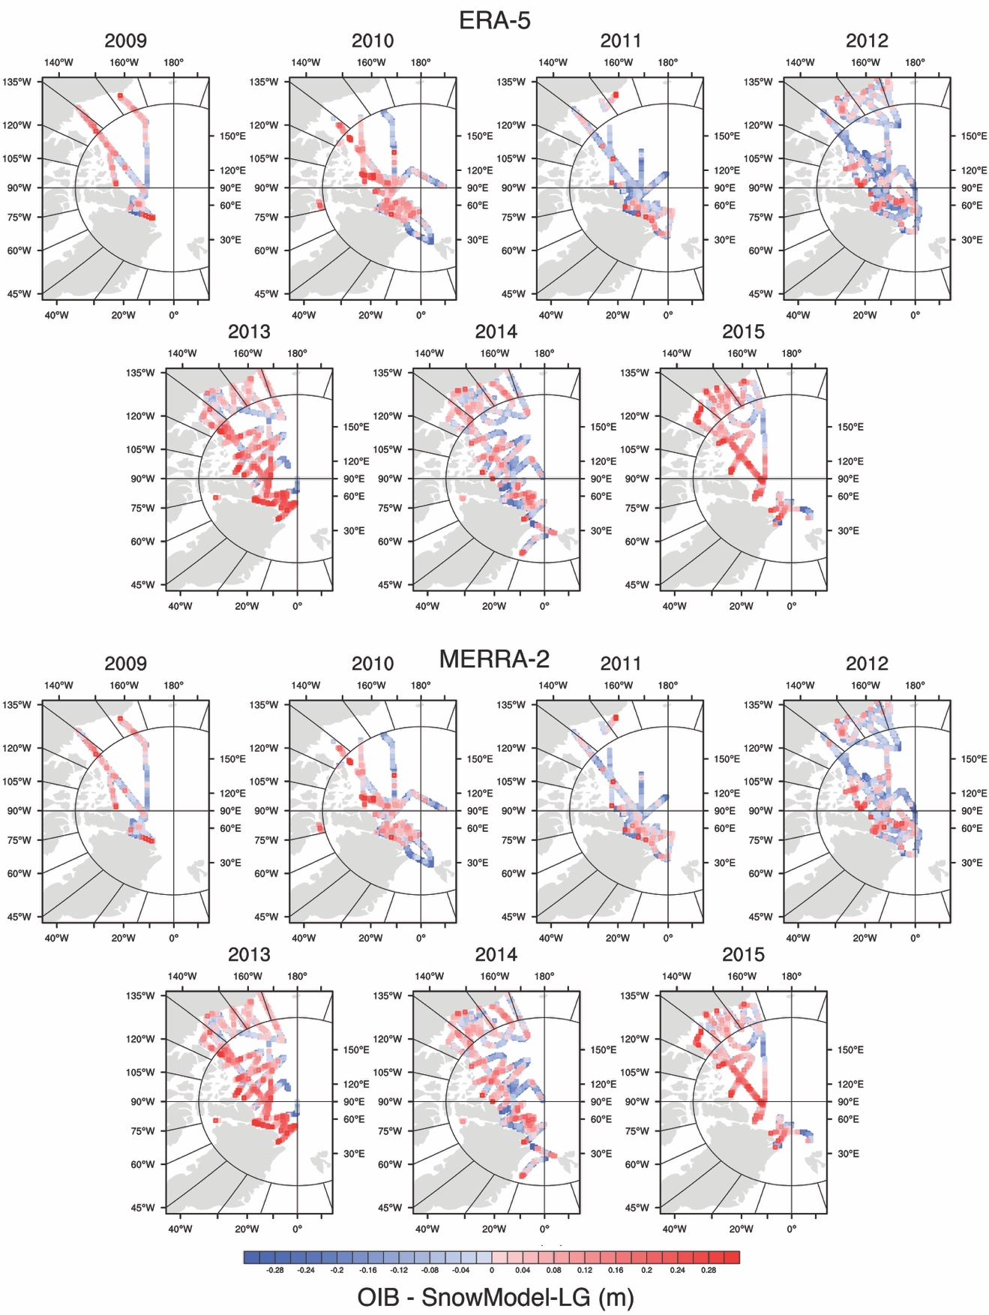

**Figure S4.** Difference in mean QuickLook OIB snow depth to that from SnowModel-LG runs using the ERA5 reanalysis (top) and MERRA-2 (bottom). Results are shown for each year from 2009 through 2015. The OIB data swaths have been widened by one 25-km grid cell on all sides to improve visibility.

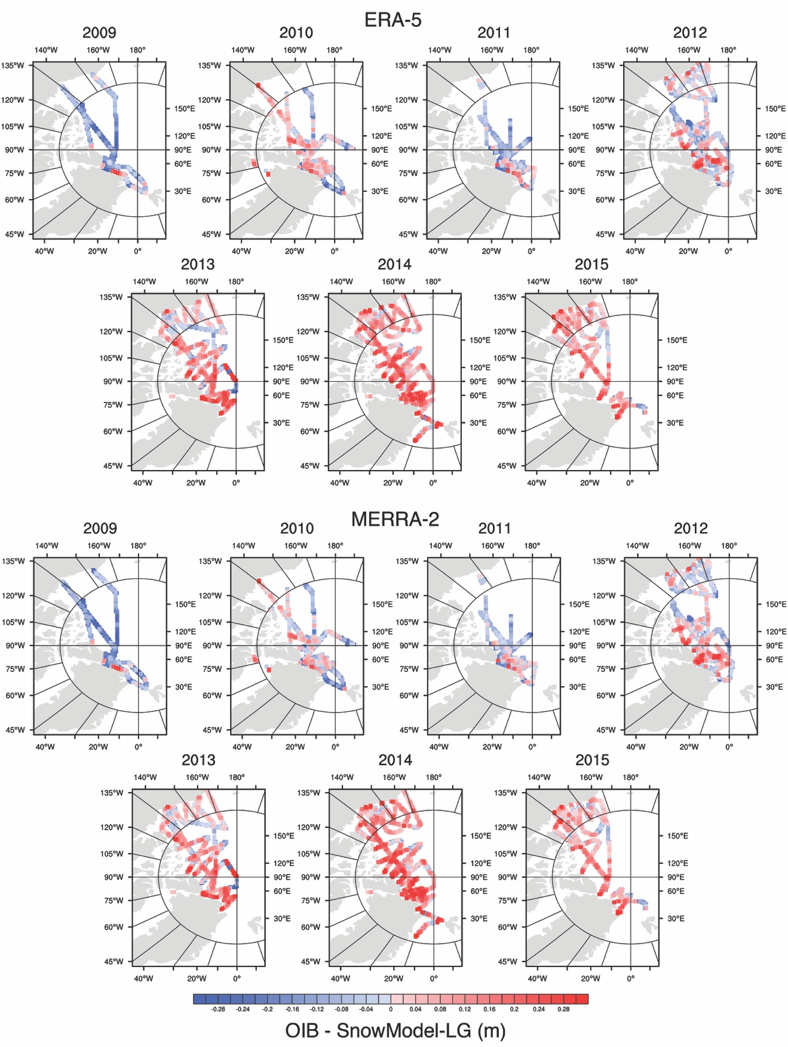

**Figure S5.** Difference in mean SRLD OIB snow depth to that from SnowModel-LG runs using the ERA5 reanalysis (top) and MERRA-2 (bottom). Results are shown for each year from 2009 through 2015. The OIB data swaths have been widened by one 25-km grid cell on all sides to improve visibility.

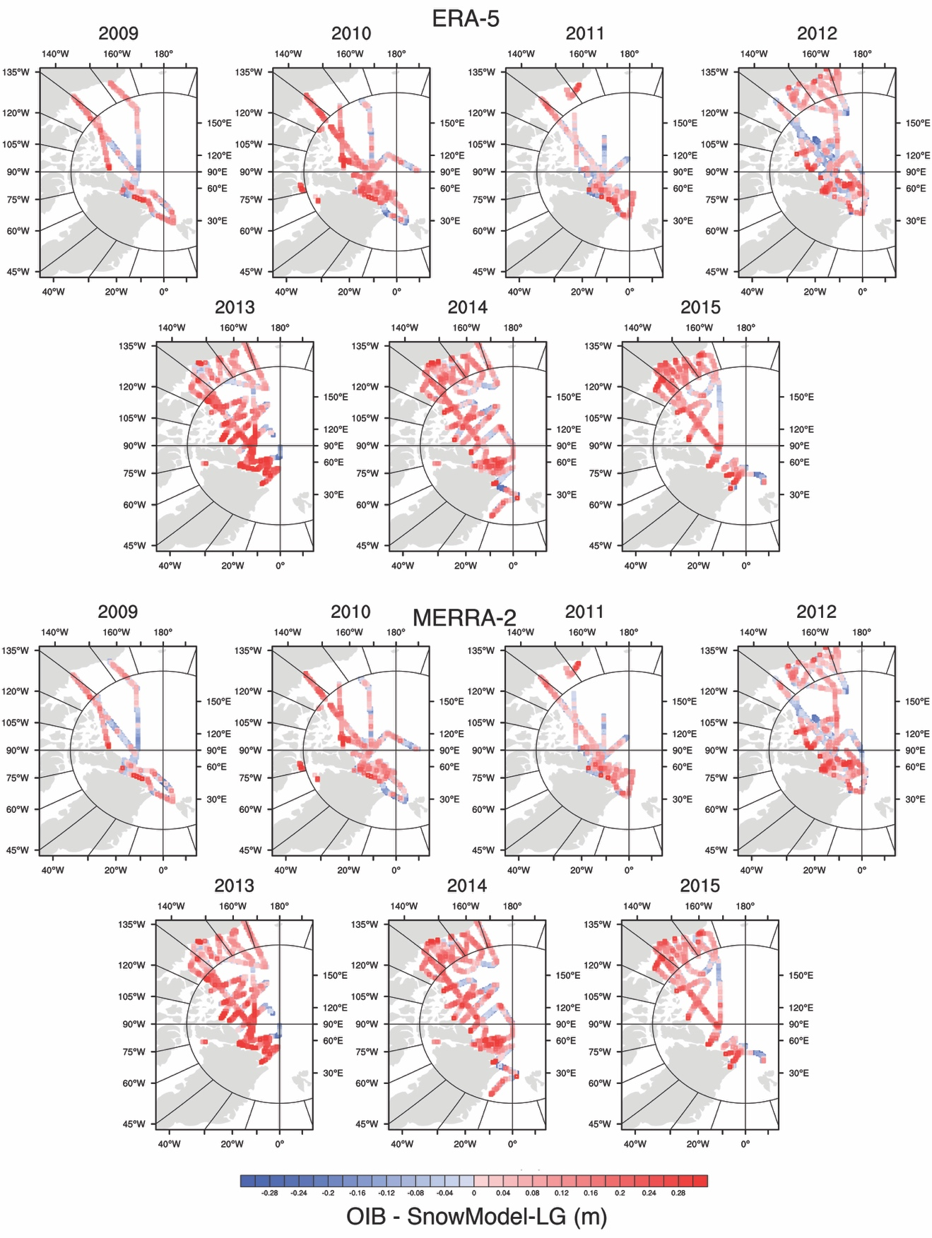

**Figure S6.** Difference in mean JPL OIB snow depth to that from SnowModel-LG runs using the ERA5 reanalysis (top) and MERRA-2 (bottom). Results are shown for each year from 2009 through 2015. The OIB data swaths have been widened by one 25-km grid cell on all sides to improve visibility.

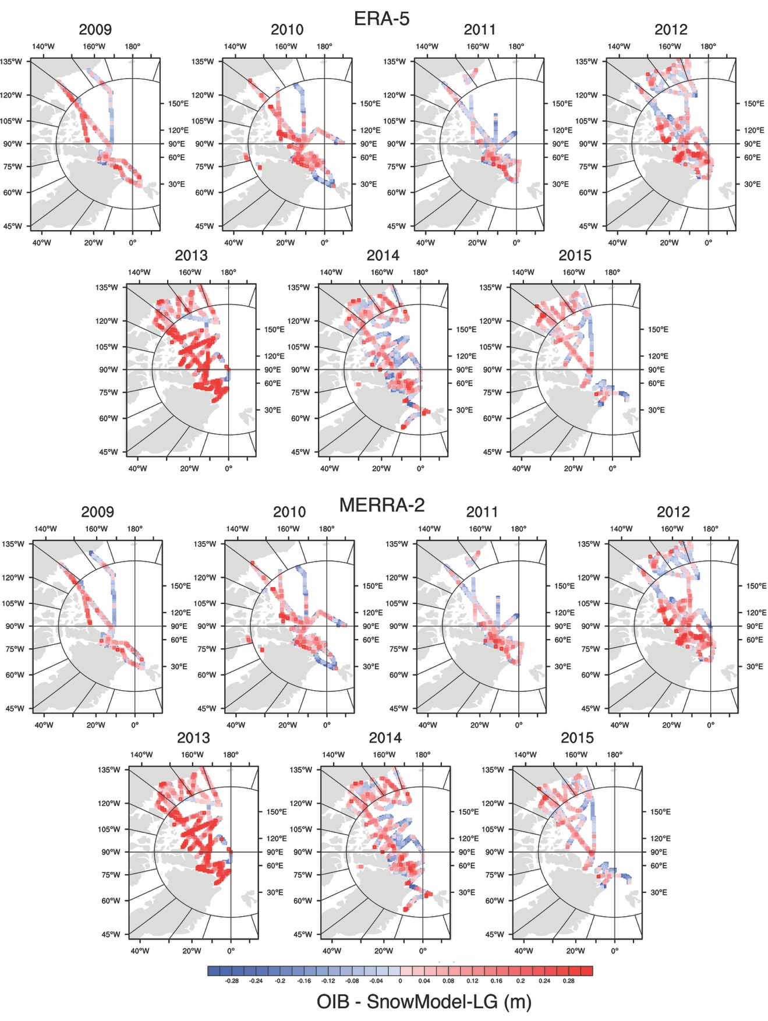

**Figure S7.** Difference in mean GSFC OIB snow depth to that from SnowModel-LG runs using the ERA5 reanalysis (top) and MERRA-2 (bottom). Results are shown for each year from 2009 through 2015. The OIB data swaths have been widened by one 25-km grid cell on all sides to improve visibility.

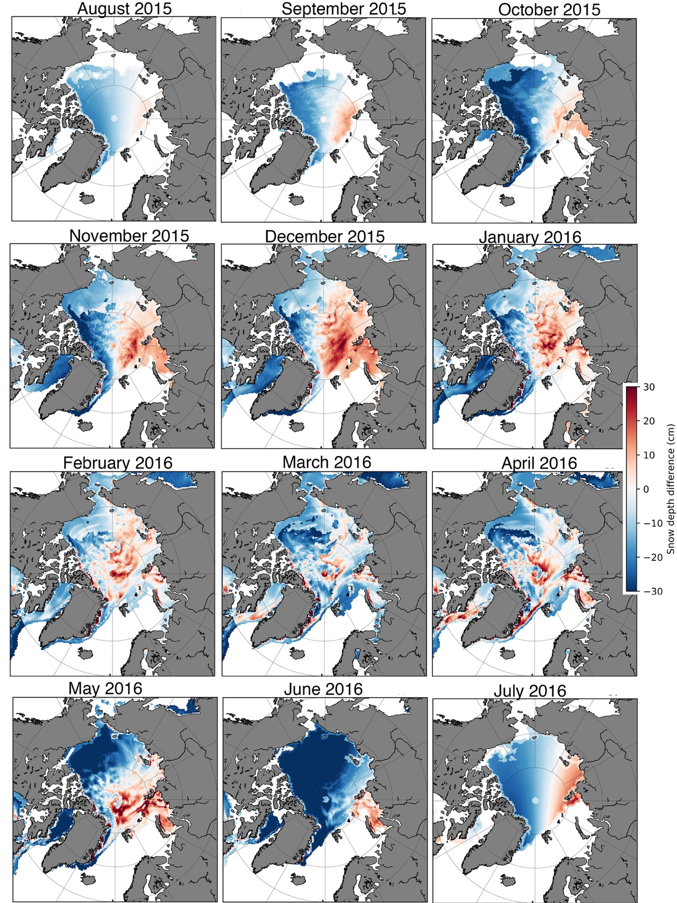

**Figure S8.** Differences between SnowModel-LG forced by MERRA-2, and the *Warren et al*. [1999] climatology snow depths in August 2015 to July 2016, with *W99* snow depths halved over first-year ice.

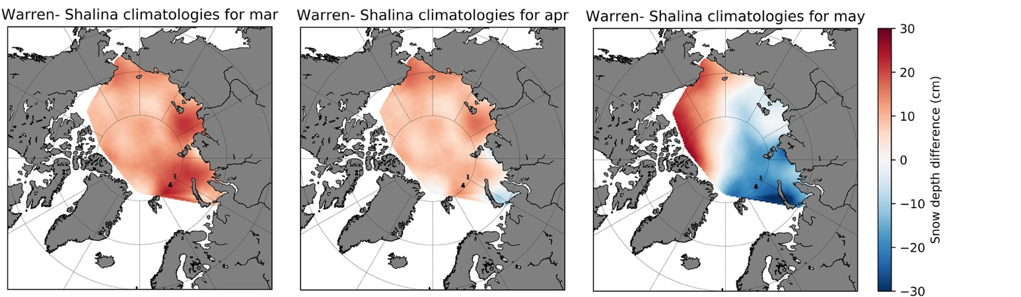

**Figure S9.** Differences between the *Warren et al.* [1999] climatological mean monthly snow depth and that from *Shalina and Sandven* [2018] in March, April and May.

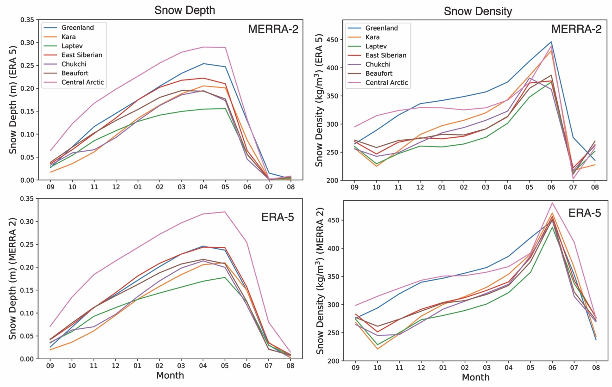

**Figure S10.** Seasonal cycle of climatological (1981-2010) mean snow depth (left) and snow density (right) for regions as defined in *Meier et al.* [2007].

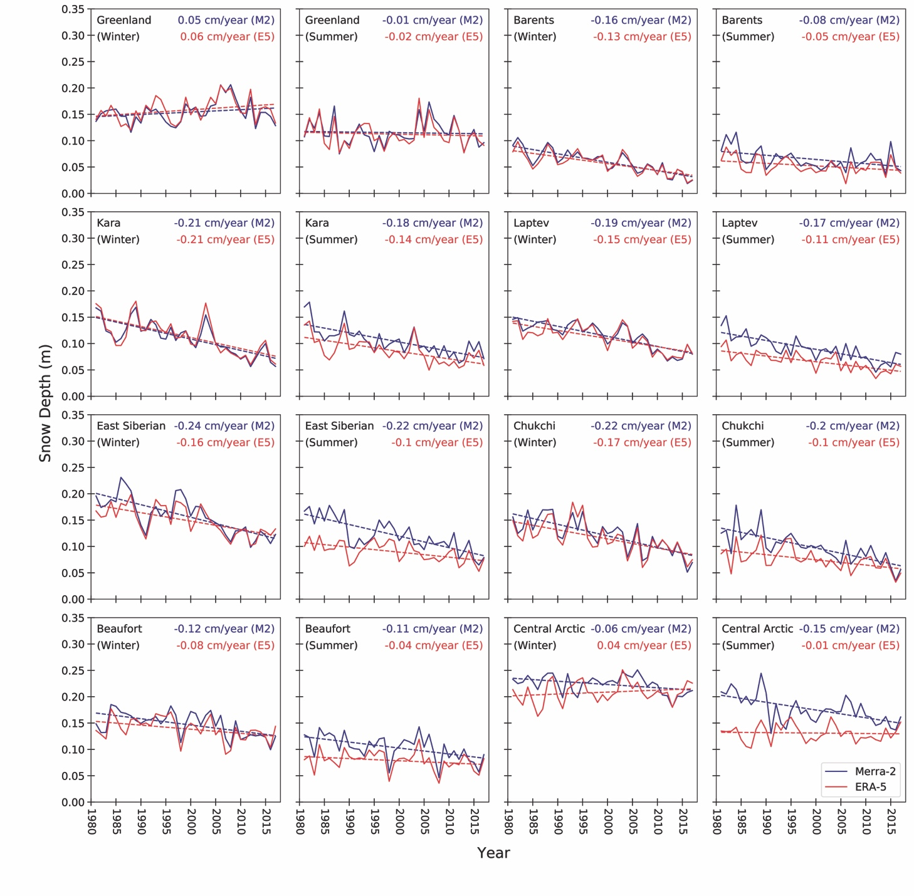

**Figure S11a.** Time-series of regional mean winter (October through March) and summer (April to September) snow depths from SnowModel-LG forced with ERA5 (red) and MERRA-2 (blue).

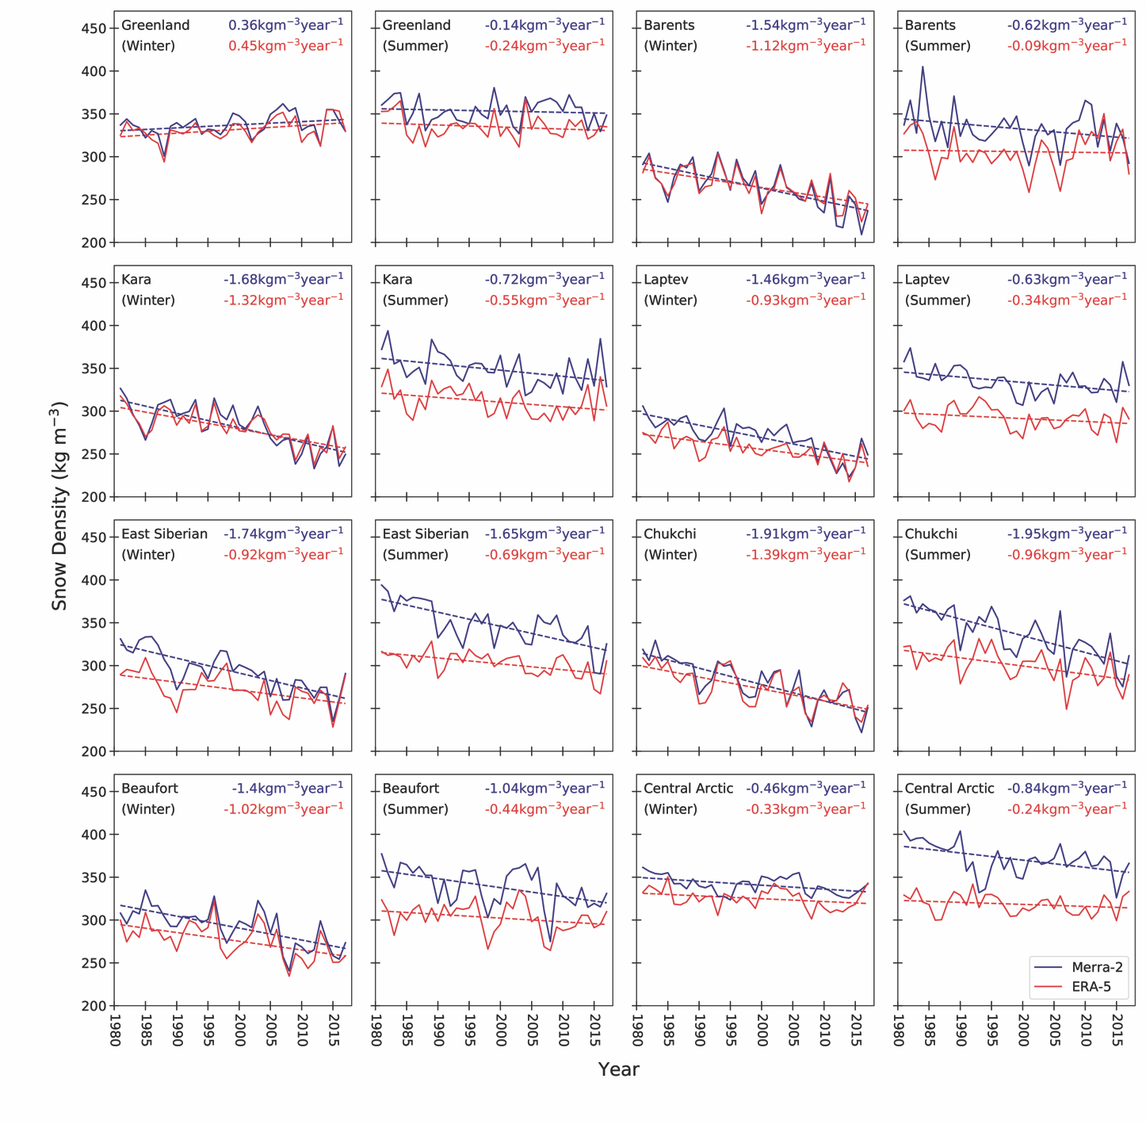**Figure S11b.** Time-series of regional mean winter (October through March) and summer (April to September) snow density from SnowModel-LG forced with ERA5 (red) and MERRA-2 (blue).

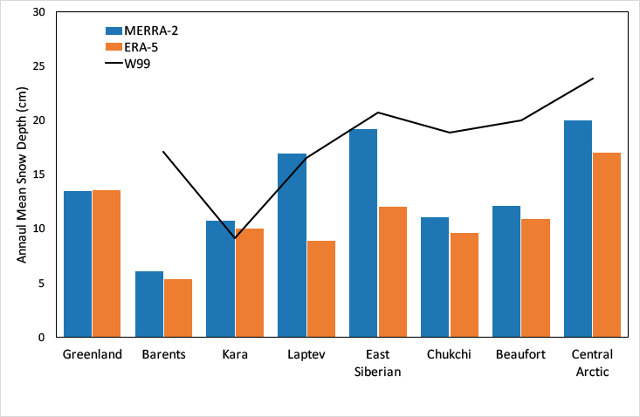

**Figure S12.** Climatological (1981-2010) annual mean snow depth for regions given by *Meier et al*. [2007].

**Correlation length scale analysis**

To investigate the characteristic length scale of SnowModel-LG (SM-LG) snow anomalies, we binned Operation IceBridge (OIB) data into the SM-LG pixels that were intersected by the flight track. These are irregularly sized bins, because some pixels are flown across more directly than others. The mean bin width was 20.3 km. 66 flights were analyzed as this is the number of OIB flights with radar snow depths existing in 10 or more EASE-grid cells over Arctic sea ice up until 2018.

We then calculated the autocorrelation functions of the OIB and SM-LG binned snow depth series. We defined the 'autocorrelation length' as the number of bins that a series could be shifted before its correlation with the original dropped below 1/e (this is the e-folding length). In **Figure S13** we show 5 examples from among the 66 flights analyzed. From the figures below, you can see that we found that OIB and SnowModel-LG data show very similar spatial correlation length of ~7.7 bins. Normally this would be translated into a correlation length in km, but this is not rigorously possible due to the irregular nature in which the OIB flight track intersects the EASE grid.

Performing this analysis for 66 flights and averaging the correlation lengths, we found that binned OIB flights have a mean correlation length (CL) of 7.61 bins. The ERA-5 SM-LG series of 7.69 bins and MERRA-2 of 7.77 bins. Physically, this means that anomalies in the OIB snow depth series have a typical length scale of 7.61 bins, which makes the features slightly finer in space than SM-LG simulates.

We also find that snow depths in adjacent grid cells are correlated, up to 7 grid cells away. The length scale of these anomalies is likely indicative of some physical process that is larger than the grid-scale, perhaps the scale of synoptic events. In this sense there are two outcomes of our analysis: (1) our correlation lengths are similar to “real” data from OIB and (2) understandable within a physical context – i.e. not being so small as to suggest that snow depths are determined stochastically due to some error with the parcel creating or gridding algorithms.

Put another way, our snow depth distribution is indicative of the synoptic scales of the forcing, which shows SM-LG is successful as our deterministic model should not be responding to a length scale below that of its forcings. Finally, Figure S14 shows SM-LG correlation lengths versus those from OIB. The correlation between OIB and SM-LG correlation lengths is 0.47 (p-value of 1x10-4). This gives us confidence that our model is not just predicting the spatial heterogeneity observed by OIB by chance, but the scale of the predicted anomalies reflects the scale of the formative processes. Were the spatial heterogeneity a product of noise introduced by the grid resolution or divergent parcel creating, we would likely not see the scaling of spatial heterogeneity.

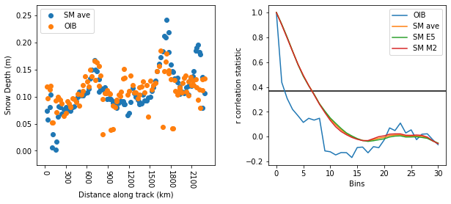  
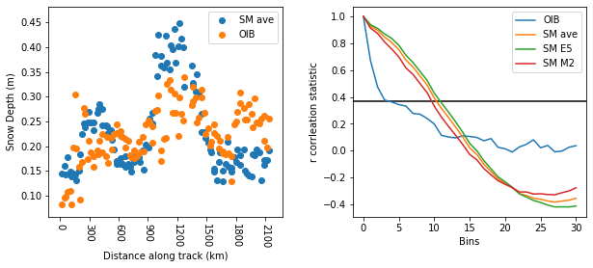

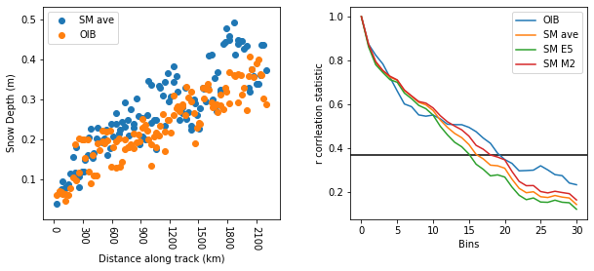 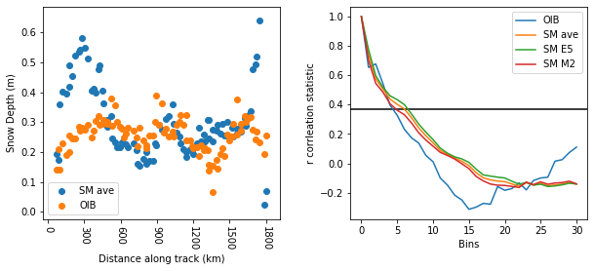

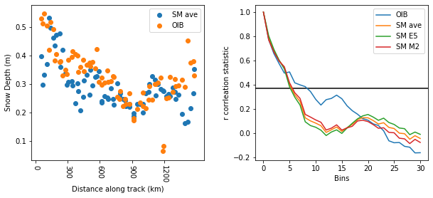

**Figure S13.** Five examples out of 66 plots for the depth agreement along the flight-line (left) and correlation length (right), one for each flight. These plots indicate our analysis approach and variation in correlation functions of both OIB and SnowModel-LG.

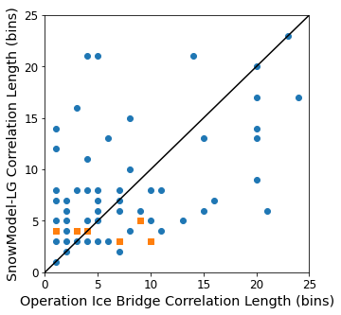

**Figure S14.** Relationship between SnowModel-LG correlation length to that from OIB. Blue circles represent flights, orange squares represent instances where two flights have the same statistics.

**Table S1**. Comparison of temporal and spatial resolution of recent new snow products for sea ice.

|  |  |  |  |  |  |
| --- | --- | --- | --- | --- | --- |
| Snow Product | Method | Data Input | Spatial & Temporal Coverage | Temporal Frequency | Reference |
| SnowModel  Snow depth and density | Sophisticated Lagrangian model | -Reanalyses (ERA-I, MERRA-2)  -NASA Team sea ice concentration, -NSIDC ice motion vectors | Whole basin  Full-annual cycle  1980-2016 | Daily | This paper |
| UW  Snow depth and snow water equivalent | Lagrangian tracking | -Reanalysis (ERA-I  -NASA -Team sea ice concentration, -NSIDC ice motion vectors | Whole basin  April only  1980-2015 | Monthly | Blanchard‐Wrigglesworth et al., 2018 |
| NESOSIM  Snow depth and density | Eulerian snow model | -ERA-I  -NASA Team sea ice concentration, -NSIDC ice motion vectors | Whole basin,  August to May  2000-2015 | Daily | Petty et al., 2018 |
| DuST  Snow depth | Calibrated Dual-Frequency Radar Freeboards | -ENVISat and ICESat (2003~2008), --CryoSat-2 and AltiKa (2013~2018) | Up to 80˚N  Mar.-Apr. and Oct.-Nov. for 2003-2008,  Oct. to Apr. for 2013-2018, | Bi-Monthly & Monthly | Lawrence et al., 2018 |
| PM  Snow depth | Gradient Ratio fitting (19/7GHz) | SMMR/SSMI/SSMI/S | Up to 87.5˚N  March | 5-day | Markus et al., 2011 |

|  |  |  |  |  |
| --- | --- | --- | --- | --- |
| Start Date | Source | Buoy Name | Start Latitude | Start Longitude |
| 2013-04-09 | AWI | S3 | 89.57 | -105.10 |
| 2013-03-16 | AWI | S4 | 71.37 | -156.53 |
| 2014-03-30 | AWI | S13 | 85.99 | -33.87 |
| 2015-09-14 | AWI | S20 | 87.49 | -114.41 |
| 2015-03-01 | AWI | S22 | 82.95 | 26.34 |
| 2015-04-20 | AWI | S23 | 83.00 | 15.66 |
| 2015-02-05 | AWI | S26 | 83.25 | 17.84 |
| 2015-04-23 | AWI | S27 | 82.78 | 16.08 |
| 2015-04-21 | AWI | S28 | 83.07 | 15.51 |
| 2015-09-12 | AWI | S30 | 88.31 | -123.45 |
| 2015-09-10 | AWI | S35 | 86.98 | 55.83 |
| 2013-01-24 | CRREL | 2013A | 76.39 | -82.89 |
| 2013-04-10 | CRREL | 2013B | 89.03 | -179.58 |
| 2013-05-10 | CRREL | 2013C | 82.60 | -62.36 |
| 2013-04-01 | CRREL | 2013D | 72.20 | -156.06 |
| 2013-04-08 | CRREL | 2013E | 89.60 | -114.16 |
| 2013-08-25 | CRREL | 2013F | 76.87 | -138.83 |
| 2013-09-04 | CRREL | 2013G | 75.69 | -141.46 |
| 2013-09-03 | CRREL | 2013H | 80.28 | 155.99 |
| 2013-09-24 | CRREL | 2013I | 74.76 | -150.45 |
| 2014-03-26 | CRREL | 2014B | 72.47 | -148.21 |
| 2014-03-20 | CRREL | 2014C | 73.50 | -137.31 |
| 2014-04-02 | CRREL | 2014D | 83.97 | -39.55 |
| 2014-04-11 | CRREL | 2014E | 89.17 | 177.21 |
| 2014-08-11 | CRREL | 2014F | 77.51 | -146.21 |
| 2014-10-09 | CRREL | 2014I | 78.94 | -149.89 |
| 2015-02-25 | CRREL | 2015A | 70.63 | -149.50 |
| 2015-03-26 | CRREL | 2015B | 73.83 | -149.28 |
| 2015-04-16 | CRREL | 2015C | 71.53 | -156.22 |
| 2015-04-10 | CRREL | 2015D | 89.60 | -17.91 |
| 2015-05-19 | CRREL | 2015E | 82.24 | 10.34 |
| 2015-08-13 | CRREL | 2015F | 80.77 | 172.72 |
| 2015-09-13 | CRREL | 2015G | 80.76 | 166.62 |
| 2015-10-03 | CRREL | 2015H | 79.48 | -148.91 |
| 2015-09-20 | CRREL | 2015I | 82.54 | -149.45 |
| 2015-09-28 | CRREL | 2015J | 78.56 | -141.36 |
| 2015-10-09 | CRREL | 2015K | 74.91 | -139.86 |

**Table S2**. CRREL buoys and AWI snow buoys used in this study.

**Table S3.** Climatological (1981-2010) monthly mean snow depths (in cm) over first-year ice regions from the passive microwave algorithm by *Markus e*t al. [2011], and SnowModel-LG forced by ERA5 and MERRA2.

|  |  |  |  |  |  |  |  |  |  |  |  |  |  |  |  |  |  |  |  |  |  |  |  |  |  |  |  |  |  |  |  |  |  |  |  |  |  |  |  |  |  |  |  |  |  |  |  |  |  |  |  |  |  |  |  |  |
| --- | --- | --- | --- | --- | --- | --- | --- | --- | --- | --- | --- | --- | --- | --- | --- | --- | --- | --- | --- | --- | --- | --- | --- | --- | --- | --- | --- | --- | --- | --- | --- | --- | --- | --- | --- | --- | --- | --- | --- | --- | --- | --- | --- | --- | --- | --- | --- | --- | --- | --- | --- | --- | --- | --- | --- | --- |
| |  |  |  |  | | --- | --- | --- | --- | | **1981-2010 Snow Depth (cm)** | | | | | **Month** | **Markus et al. 2011** | **ERA5** | **MERRA-2** | | January | 15.4 | 13.3 | 14.2 | | February | 16.1 | 15.5 | 16.6 | | March | 16.8 | 17.3 | 18.8 | | April | 17.0 | 18.6 | 21.0 | | May | - | 20.9 | 24.4 | | June | - | 10.1 | 21.1 | | July | - | 0.2 | 4.4 | | August | - | 0.6 | 0.8 | | September | - | 3.4 | 3.5 | | October | 14.5 | 6.3 | 6.9 | | November | 14.3 | 8.8 | 9.6 | | December | 14.7 | 10.9 | 11.6 | |

Movie S1. Evolution of snow depth during 2014. Type or paste caption here (upload your movie(s) to AGU’s journal submission site and select, “Supporting Information (SI)” as the file type. Following naming convention: ms01.